Experiment XIII

**Aim**: Write a program to perform constant propagation.

Algorithm

1. Start
2. Input the maximum number of expressions
3. Input the expressions into a structure variable.
4. Convert the operand1 and operand2 to integers.
5. If the operator is ‘+’, ‘-’, ‘*’, ‘/’, or ‘=’, perform the corresponding operation and store it in res.
6. Replace the operand occurring in the following expressions with this value res.
7. Display the optimized expressions
8. Stop

Output

Enter the maximum number of expressions: 4

Enter the input:

= 3 - a

+ a b t1

+ a c t2

+ t1 t2 t3

Optimized code is:

+ 3 b t1

+ 3 c t2

+ t1 t2 t3

Screenshot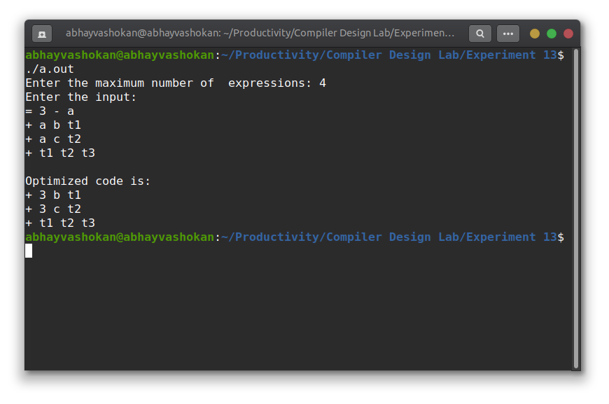

Readme

1. Compile and run the C program using the command

**gcc 2Abhay-P13.c && ./a.out**

2. Enter the maximum number of expressions

3. Enter the expressions

4. The optimized code will be obtained as output.

**Result**: Successfully implemented a program to find the ε - closure of all the states in an NFA with ε transitions.